# Assignment 4 (Parallel Sorting)

Conclusion:

When cutoff < array size, parallel sort is more efficient than system sort;

Number of thread influence parallel sort performance / relationship similar to cos(x)

Result:

When Array size unchanged and is 2000000

**when number of threads is 4:**

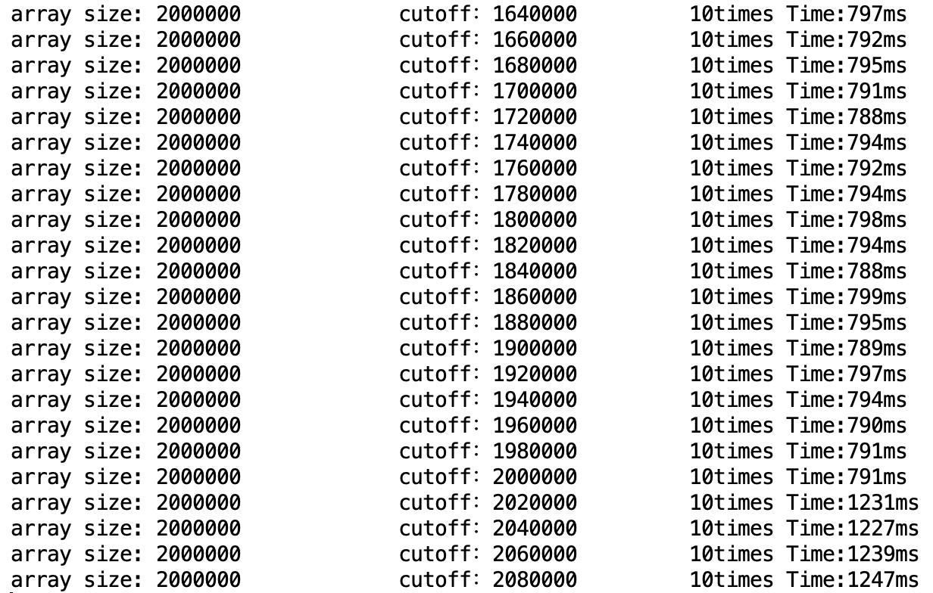

**when number of threads is 8: When number of threads is 16:**

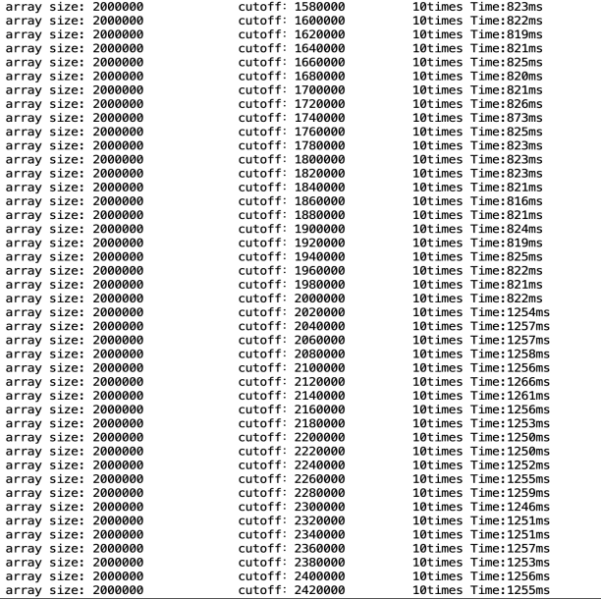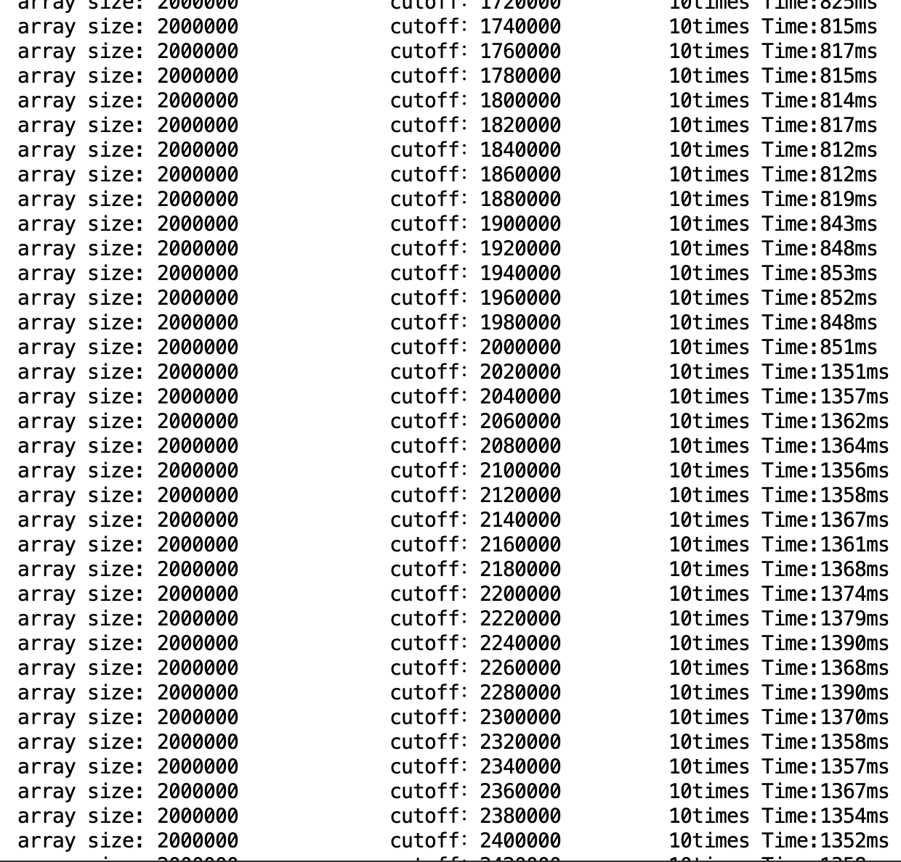

**When number of threads is 128:** **When thread count is 512:**

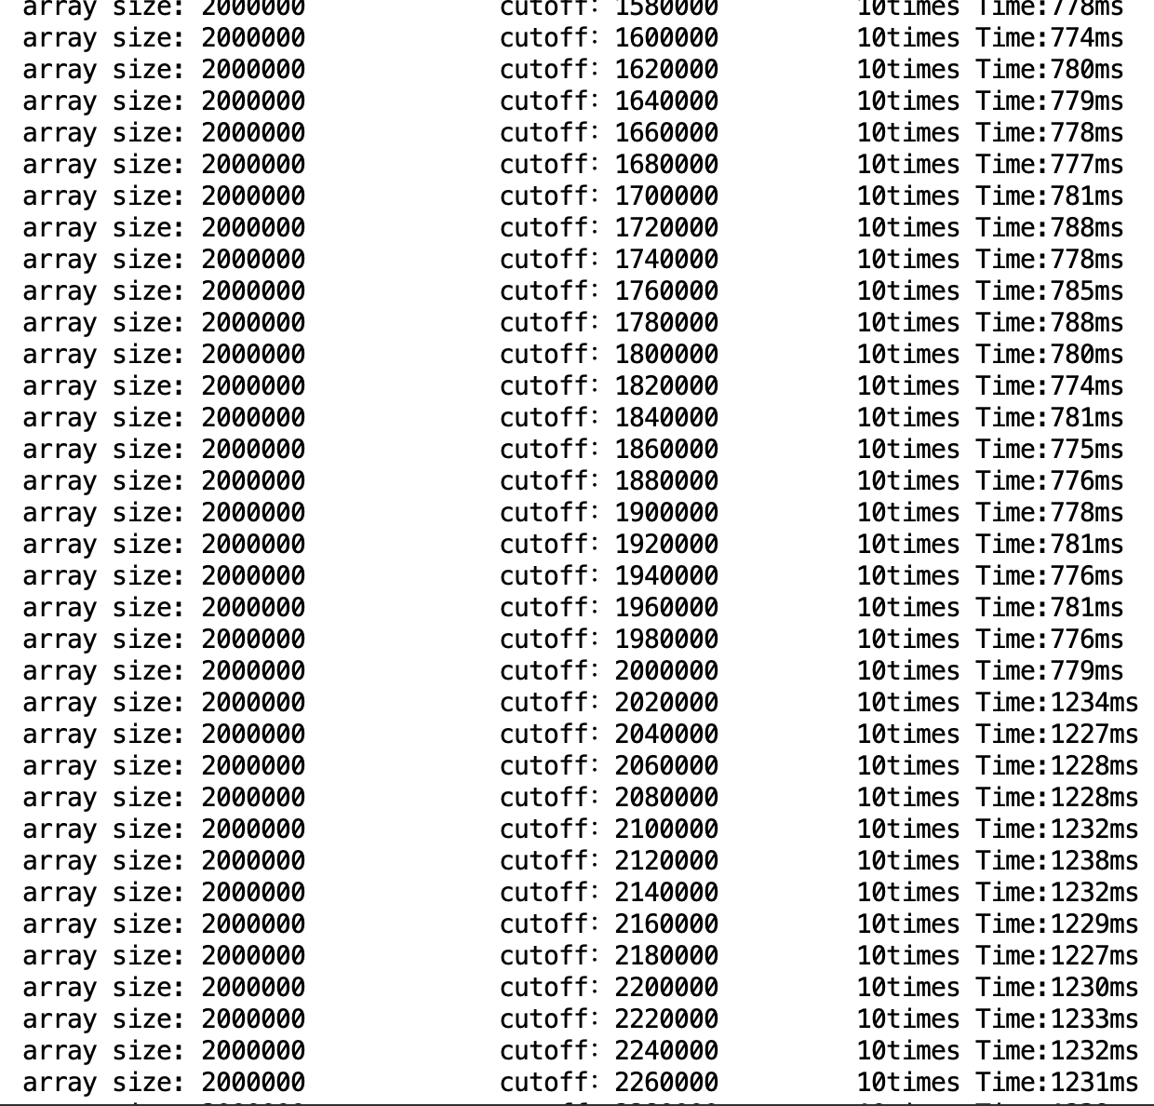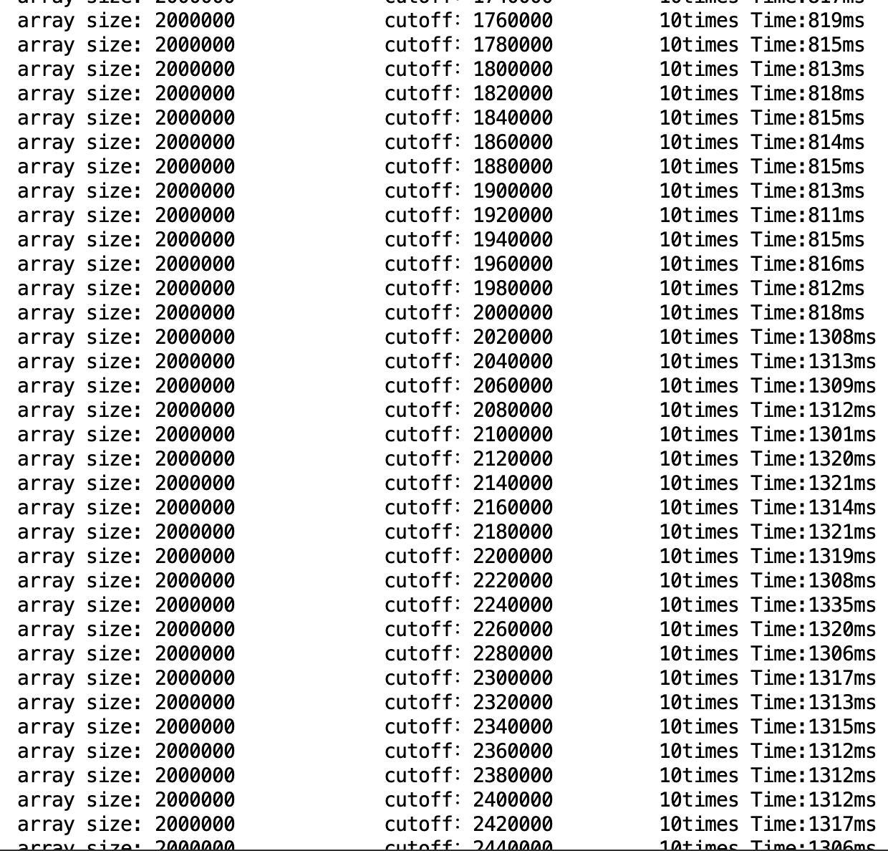

When number of threads is 128:

When array size is 6000000:

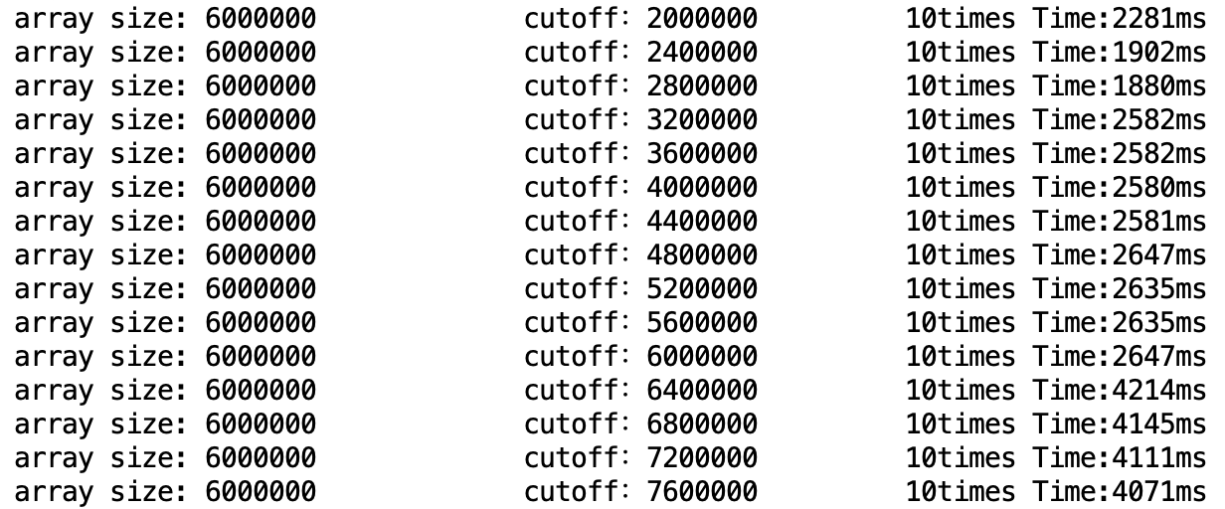

When array size is 5800000:

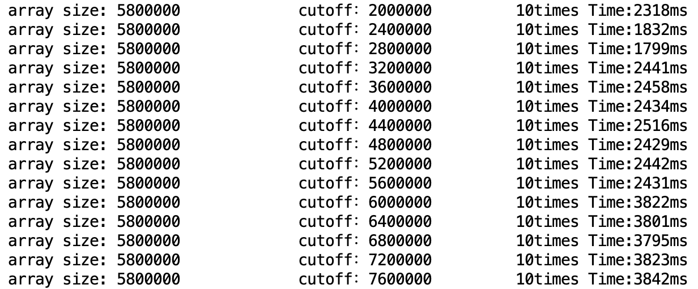

When array size is 3100000:

